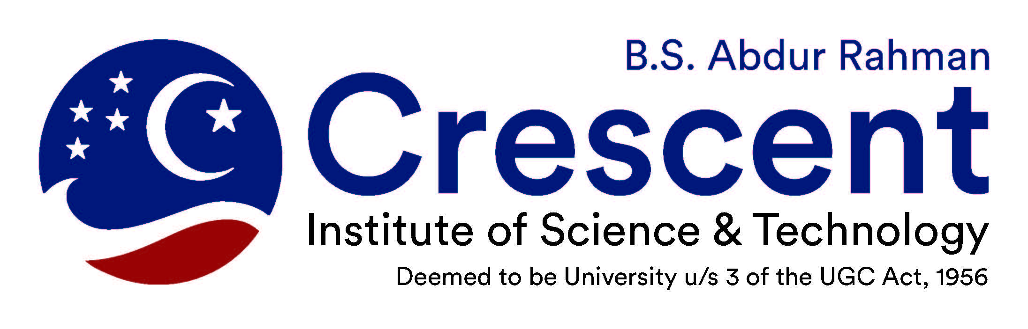

Institute of Science & technology

CRESCENT INNOVATION & INCUBATION COUNCIL

Intellectual Property Policy

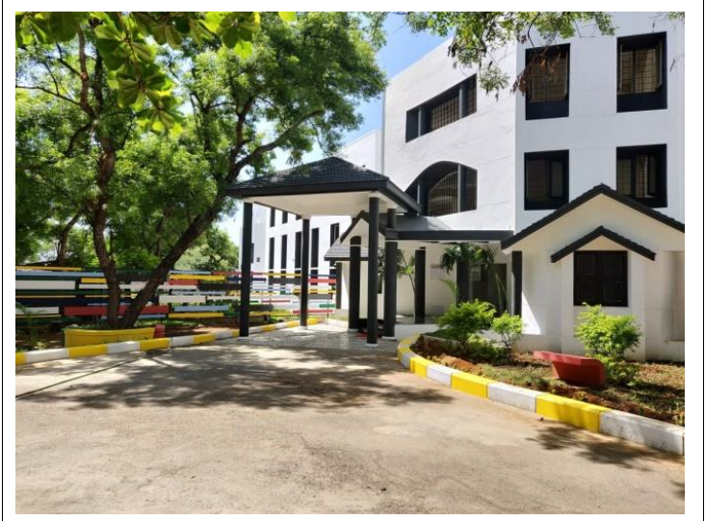

Crescent Intellectual Property Rights

 | CONTENTS
S. No | Title | Page No.
1 | Preface | 1
2 | Introduction to IPR | 2
3 | About CIIC | 3
4 | Services of CIIC | 4
5 | Objectives of Crescent IP Policy | 4
6 | Ownership of IP | 5
7 | Internal Evaluation of IP | 6
8 | Publication Based on IP | 6
9 | Patent Filing Process | 7
10 | Maintenance of Patents | 7
11 | Patent Fee | 8
12 | Transfer of IP | 8
13 | Revenue Sharing | 9
14 | Copyrights | 9
15 | Filing Procedure for Crescent Personnel | 10
16 | Filing Procedure for Individuals/Affiliated | 11
 | Colleges/SME’s/Companies


Preface

Intellectual Property (IP) refers to creation from the mind of any person (inventor) such as inventions, innovations, literary work, artistic works, designs, symbols, names, logos, images. IP plays an important role in providing a competitive edge to any organization. The tangible assests like inventions, designs, software, brand name and other creative and innovative ideas are more valuable than physical assets. It is necessary to protect these creations in order to enable organizations to earn recognition or financial benefits. In this scenario, Governments of various countries protect the innovative ideas of the inventors through Intellectual Property Rights (IPR). Recently, IPR has become a central issue in the developed and developing countries.

The faculty, research scholars, scientists, students and other personnel of Crescent are actively engaged in various research and development activities of diversified nature. Many of these research and development leads to different forms of IP, which are likely to be commercially exploited unless protected by IPR. In this scenario, Crescent Innovation & Incubation Council (CIIC) encourages, facilitates, promotes and safeguards scientific investigations and research of Crescent Personnel and others. CIIC is acting as nodal centre for carrying out all the activities related to IP. For the convenience of the inventors, CIIC has come out with this booklet “Crescent Intellectual Property Policy”. This booklet will give an idea to all the inventors about the functioning of CIIC.

Crescent IP Policy aims to lay down the process for promotion and support to innovators of Crescent Personnel and others for converting their innovative works into IP. Crescent IP policy also aims to set forth guidelines for ownership of IP developed at Crescent by Crescent personnel, those directly or indirectly associated with Crescent, either in-house or outsource, sponsored unless specially covered by a policy to the contrary. CIIC will address specific cases by using this Crescent IP policy document as guidelines. The IP policy of Crescent is expected to fulfil the commitment of the Crescent in order to promote academic freedom and provide a beneficial environment for research and development.

CEO, CIIC

1


Introduction to IPR

Intellectual Property Rights (IPR) denotes the specific legal rights of the inventors to hold and exercise Patents, Trademarks, Copyrights, Industrial Designs, etc. IPR aims to exclude third parties from exploiting the protected subject matter for a certain period of time (normally 20 years), without explicit authorization from the right holders.

IPR owners can use or disclose their creations without fear of loss of control over their usage during the course of dissemination of their creation/invention. IP confers of exclusive rights in relation to the particular form in which ideas/information are expressed/ manifested in the following manner.

- New and useful scientific and technical advancements in the form of innovations, inventions, products and processes, computer hardware and software, materials, biological varieties, etc. which are patentable.

- Industrial and architectural designs, models, drawings, creative, artistic and literary works, teaching resource materials, generated records of research including thesis, a dissertations, etc. which are copyrightable.

- Trademarks, service mark, logos, etc.

2


About CIIC

Crescent Innovation & Incubation Council and Trademarks was established in Crescent in the year 2018 as per the approval of Syndicate of Crescent at Board meeting. CIIC was established to create awareness and offer assistance to academicians, researchers, entrepreneurs and innovators to identify, protect and manage IPR effectively. CIIC actively involves in educating the importance of IPR for various communities. CIIC has to its credit a well established IP policy, approved by Crescent Board. CIIC is functioning as the nodal centre for Industries, Small and Medium Entrepreneurs, Educational and Research Institutions for IPR related matters.

CIIC provides IP services such as Patent Search, Patent Specification Drafting and Filing of Patent Applications at Chennai Patent Office for a nominal amount to students, research scholars and faculty of Crescent, Affiliated colleges of Crescent, SME’s and Large Establishments.. Similarly, CIIC is also filing application for Designs, Trademark and Copyrights to Crescent Personnel and others. CIIC is acting as correspondence for the applications filed by faculty, researcher and students of Crescent personnel

CIIC very keen to conducted number of Certificate Courses on Intellectual Property Rights in collaboration with Anna University &Tamil Nadu Technology Development and Promotion Center (TNTDPC) of Confederation of Indian Industries (CII), Chennai.

3


Services of CIIC

- Filing of Patents:

CIIC has expertise and experienced professionals to do patent searches (both from free and paid databases), patent specification drafting, patent filings and related works.

- Design Patents:

CIIC carries out design patent search and filing of design patents applications for shape, configuration, pattern, composition of lines, colours applied to any products.

- Trademarks:

CIIC carries out trademark search and filing trademark applications for logo, symbol, design, image, sound, colour, slogan, smell, word, phrase or combination of these elements.

- Copyrights:

CIIC assists in copyright filing related to the original work of literary (books, lab manuals, etc), artistic (painting, sculptures, photographs, etc), dramatic, musical work, cinematographic films, sound recording, software programme, etc.

- Awareness Programme:

The CIIC regularly conducts awareness programs to educate the importance of IPR for faculty, students, research scholars, R&D institutions, SMEs, large establishments, etc (Please refer CIIC website for further information).

Objectives of Crescent IP Policy

The objectives of this Crescent IP policy are:

- To foster, stimulate and encourage creative activities in the widest sense in all the areas in which academic, consultancy and research programmes are offered by Crescent.
- To protect the legitimate interest of faculty / scholars / students of Crescent and Non Crescent and to avoid as far as possible conflict of opposing interests.
- To lay down a transparent administration system for the ownership and control of intellectual properties and sharing of the revenues generated and owned by Crescent.

4


Ownership of IP

Crescent shall be the owner, with the creators specially stated as inventors for all the intellectual property inventions, software designs and specimens created by the creators who include faculty members, research scholars, students and those who make use of the resources of Crescent.

The Inventions created by Crescent personnel, without using Crescent resources and created outside their assigned/normal duties/areas of research /teaching shall be owned by the creators and the revenue generated out of such creations shall be shared in the ratio of 75:25 between the creator and Crescent respectively.

If an IP has emerged as a result of an Institutional/Industrial consultancy, sponsored to Crescent the concerned industry and Crescent shall own the IP. This however will not apply to those IP that are covered under specific MoU’s where the action shall be carried out as per the provisions of the MoU’s. If the IP is a result of funds sponsored by an outside agency, then the IP will be shared between Crescent and the sponsoring agency on case by case basis, as per MoU/Agreement/Undertaking between Crescent and the outside agency.

A computer software may be patented, copyrighted, trademarked depending upon the IP content. A copyright software may be distributed for research and teaching purposes by its creator after obtaining appropriate undertaking to the effect that it will not be used for commercial purpose nor will it be transferred to any other party without explicit permission of Crescent.

5


Internal Evaluation of IP

CIIC will coordinate the activities of evaluating, protecting, licensing and managing the IP generated by Crescent. Further, it shall provide guidance to all Crescent personnel and facilitate protection and deployment of intellectual property issues of ownership, confidentiality, suitable advice from experts, disclosure, patentability and transfer.

An invention will be patented only if it has commercial value and viability for production and marketing. A Patentability committee consisting of Director (CIIC), Director, Centre for Technology Development and Trasfer (CTDT), Director, Centre for Research and other expert member/s to the extent required shall decide the commercial value and related aspects on case by case basis. The committee shall also act to the best of its knowledge to avoid scientific misconduct in research and developmental activities of Crescent.

Publication Based on IP

For patentable IP, it is essential that the patent protection is filed before the publication or disclosure of it in any other form of public domain.

6


Patent Filing Process

Provisional patent application that may arise out of projects/research activities of Crescent may be directly applied by the Creators/Inventors after obtaining formal permission from CIIC on their own Cost.

After submitting the complete specification, in the Indian Patent Office, CIIC will guide the inventors on the protection of invention in foreign countries. However, the cost towards filing of patent in foreign countries will be borne by the inventors.

Maintenance of Patents

For the inventions developed at the Crescent with the Crescent personnel and the inventors who wish to protect the invention, it is mandatory that the creator has to disclose the creative work by using an Invention Disclosure Form (IDF) (Annexure 1 and also available in the CIIC website). The inventors shall assign the rights of the disclosed invention to Crescent. All IP related information that is disclosed to Crescent is confidential.

Confidentiality shall be maintained till the dates stipulated in the contract between the concerned parties. Once the IPR is ensured, (published in the Journal of Indian Patent Office) the inventor/creator is encouraged to publish the work in the interest of general public.

7


Patent Fee

The Crescent Innovation & Incubation Council shall bear 75% of the Patent filing fee and 25% shall be borne by the inventor. Crescent will pay the patent fees for the first seven years in all cases when patent is taken by Crescent. If it is a joint patent with sponsoring agency, then the patenting cost will be equally shared. If the other agency does not show interest in such process, Crescent can either continue the patent by paying the fees for its full term or withdraw application for the patent protection, at its discretion.

Transfer of IP

Crescent shall strive to identify potential licensee for the IP to which it has ownership. Generally creators are expected to assist the transfer of IP. Crescent may contract any of the technology management agency which manages the commercialization of IP. If exclusive rights of IP have not been assigned to the third party, creators may enter into a contract with any potential licenses on their initiative maintaining confidentiality and taking care through Non Disclosure Agreement with the concurrence of Crescent. The inventor/creator has the first right on the terms and conditions that are agreeable by Crescent.

8


Revenue Sharing

The revenue sharing arrangements are as detailed below:

60 % (sixty percent) of the total revenue (lump sum payment, royalty or any other form) accruing from the commercial exploitation of IP owned by Crescent shall be credited to creators. 40% of the revenue shall be credited to Crescent.

Copyrights

Ownership of the copyrights:

Crescent shall be the owner of all copyright works including software and all connected teaching materials designed and developed by employees of Crescent.
Further, Crescent shall also be the owner of copyrights of works produced, including software and all teaching materials developed by persons not directly associated with Crescent, provided Crescent has made its contribution in the form of any of the resources.
The ownership of copyright by Crescent will in no way deprive the claims of the creator/author to publish his/her contribution in a scholarly and intellectual way and they have authority to improve, publish and propagate their works.

9

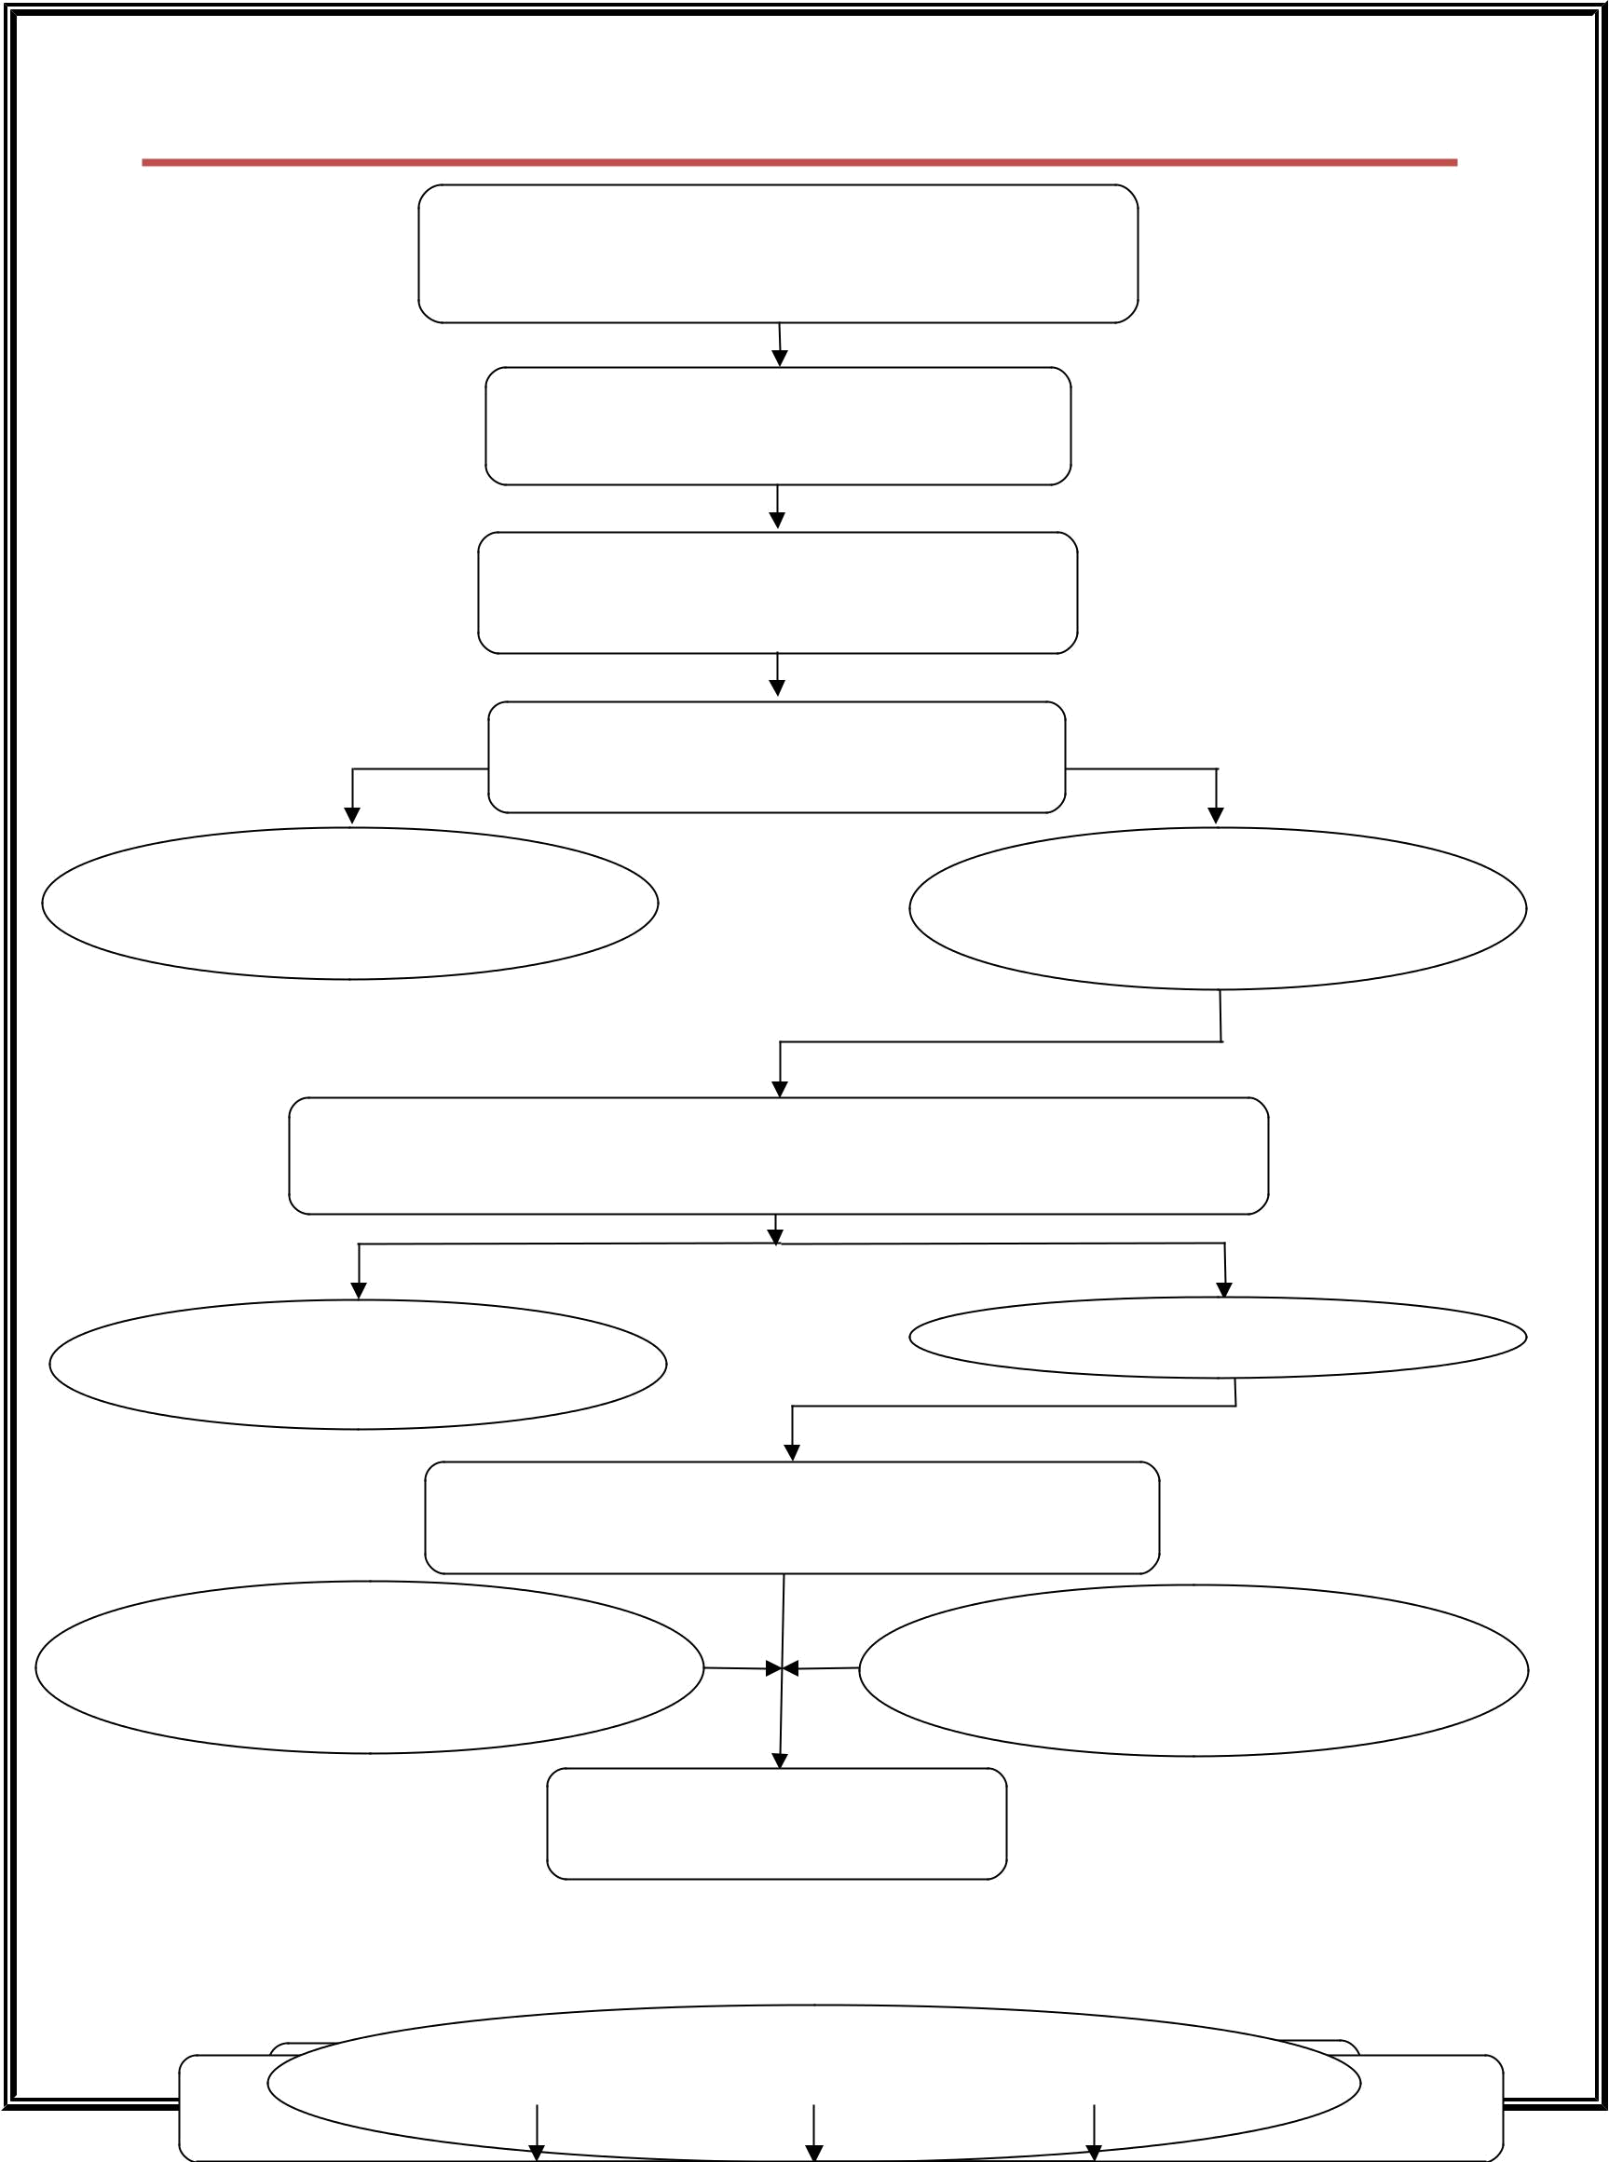
Patent Filing Procedure for Crescent Personnel

Submission of Invention Disclosure Form (IDF)

by Inventors

(Download from CIIC Website)

Prior-Art Search Using Free and Paid

Databases by CIIC

Submission of Search Report to

Inventors by CIIC

Reply to Search Report by the

Inventors to CIIC

If there are similar Literature/

Work/ Patents available no

further process

If it meets the criteria such as

Novelty, Non-Obviousness and

Industrial Application

Conduct of Patentability Meeting with Director CIIC, Director CTDT

and Director Research and an External Member

Rejected if Invention doesn’t | Approved
meet the Patentability Criteria

Drafting of Complete Specification and Preparation

of Forms related to Patent Application

Submission of Agreement between Inventors & Crescent (Download from CIIC Website)

25 % filing charges will be borne by

Crescent Personnel and 75%

will be borne by Crescent

Filing of Patent Application in

the Chennai Patent Office

10

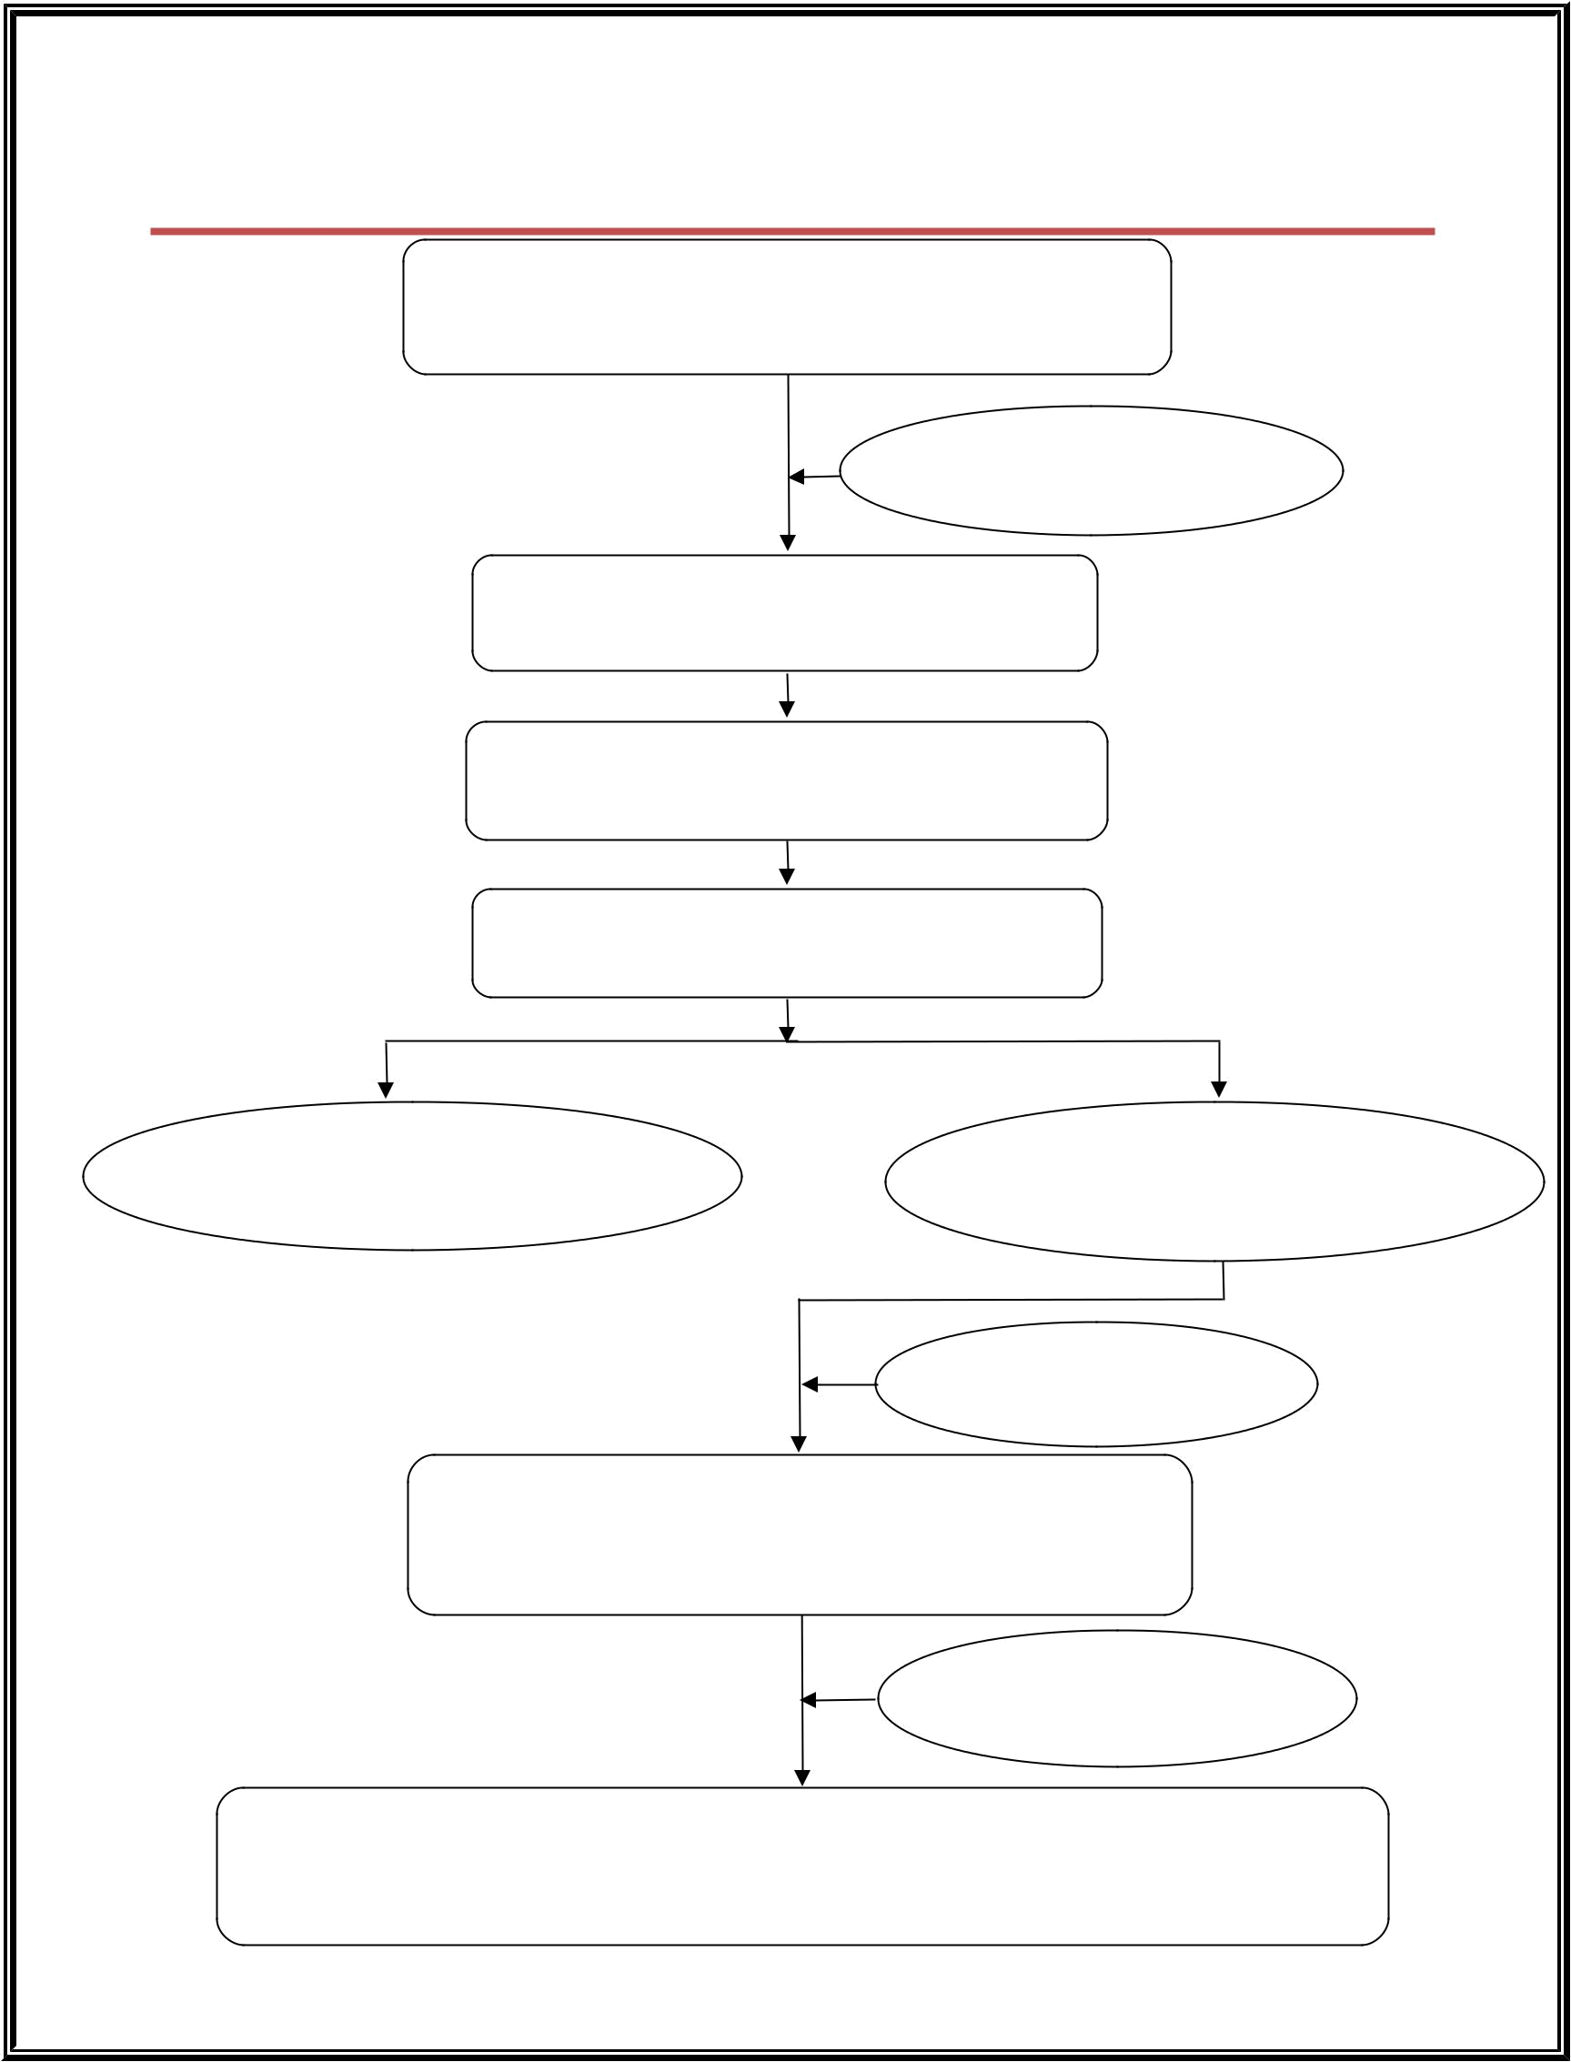
IP Filing Procedure for Individuals/Affiliated

Colleges/SME’s/Companies

Submission of Invention Disclosure Form (IDF)

by Inventors

(Download from CIIC Website)

Collecting Search Fee

from Inventors

Prior-art Search Using Free and Paid

Databases by CIIC

Submission of Search Report to Inventors by

CIIC

Reply to Search Report by the Inventors to

CIIC

If there are similar Literature/ Work/

Patents available no further

process.

If it meets the criteria Novelty, Non-

Obviousness and Industrial Applicability

Collection of Drafting

Fee from Inventors

Drafting of Complete Specification and
Preparation of Forms related to
Patent Trademark/Copyright/Design Application

Collection of Patent

Office Fee from Inventors

Filing of Application in the Chennai Patent Office for Patent,

Chennai Trademark Office for Trademark, Kolkata Design Office for Design

Applications and New Delhi Copyright Office for Copyright Applications

11



For Further Details Contact

BSA Crescent
Institute of Science & Technology
Crescent Innovation & Incubation Council
GST Road, Vandalur, Chennai 600048
http://crescent.education/
Contact Person: M Parvez Alam, CEO
Contact No: 9551076617; Phone: 2775 1345 Extn: 488
Email: ceociic@crescent.education

